Website words part 1

What is Zentangle?

The Zentangle method is an easy-to-learn, relaxing, and fun way to create beautiful images by drawing structured patterns.

The materials are elegantly designed, crafted and presented. Rick Roberts and Maria Thomas who created Zentangle art, chose Sakura Pigma Micron pens to complement their museum quality papers for long lasting, beautiful results.  Sakura Pigma 01 and other Sakura pens, a pencil,  a tortillion , and Original Zentangle Tiles.

A tile is a small piece of paper, originally a 3 1/2 inch square white piece of handmade 100% cotton paper from Italy. Tiles, at the end of a Zentangle drawing class, are laid out next to each other, creating a Mosaic.

Stress relief is another one of the miracles of zentangle. It has a mindfulness aspect. As you focus on the one line at a time that you’re drawing, you are not thinking about the dishes or your job.

In “The Book of Zentangle” it says; , “Be thankful for this opportunity to treat yourself to this moment of creativity.”

Who am I?

My name is Lisa Hoesing. I live in Santa Cruz, CA. I have an MA Ed from UC Santa Cruz. I took the Certified Zentangle Teacher, (CZT), training in 2014. Since then, I’ve been teaching classes in person. I am a retired computer programmer. Over the years, before I started Zentangle, I did mostly what was considered fiber arts.

“High tech, high touch”. -John Naisbitt

That has been my motto. While I worked with computers, at home I worked with highly tactile fables..

You may think of fiber arts as weaving, knitting and sewing. Yes, I did those. I also made paper. It started when I took a Chinese pushpin class and they had us painting on beautiful Japanese papers then I learn to make my own and I spent many years making large art pieces of paper and small pieces of paper to give away.

I enjoyed being a member of The Friends of Dard Hunter. They are now called The North American Hand Papermakers. I made a lot of paper and I love hand made paper.

Zentangle brought joy and relaxation into my life.

One of the main reasons I love teaching Zentangle is that it brings joy into people’s lives. There is nothing more fun for me than watching the way anyone, child or adult, looks at their tile and realizes that they may have started the class claiming they were not an artist, but at the end of the class they have made a beautiful piece of art.

When Covid put us in lockdown in March 2020, I had just said I would teach somebody. I had to call him and say, “I can’t meet with you.” I offered him the chance to take my class free while I tried to learn to teach on zoom, something I have never done. He very kindly, said yes. I taught several classes and I learned Zoom myself.

I began to offer classes free to various other communities as stress relief from the impacts of Covid. I ended up teaching twice a week.

Please look for my Upcoming Classes” to register.

Upcoming Classes

Offered

Wednesday 5:00-5:30 pm

We are working through a series of classes focusing on “official” tangles. Aka Headquarters Tangles,

Please email me for information.

Saturday 4:00-5:30 pm.

These classes are ZIA, Zentangle Inspired Art tiles. They are often centered around a holiday or seasonal theme.

Please email me for information.

My Zentangle Story

I recently found a tile from 2010. I have tiles all over my house.

In 2010, I discovered Zentangle while looking for a way to relax and meditate. I have always had trouble sitting still and meditating. Zentangle allowed me to move, by drawing,,while meditating, I was also attracted to Zentangle’s artistic side.

I started drawing tiles most nights before I went to bed. Zentangle helped me calm down and get to sleep. I discovered that it also helped ease my chronic pain. As I focused on my drawing I was not focusing on my pain. After 15 minutes of drawing, my pain level has decreased. This is a wonderful benefit and I am not the only one who noticed it.

I found myself wanting to teach others this marvelous technique.

Historically, in any job I had, I was always the one to teach others whatever I knew. I have taught computer skills at many places around Santa Cruz, including Cabrillo College, Dominican Hospital, Santa Cruz County Offices, and in the student labs at UCSC.

It wasn’t until 2014 that I managed to get into the CZT training class number 14.

Since then, I have continued my own practice, and taught classes in person.

I have also been privileged to be able to take classes locally with Rick Robert’s, Maria Thomas, Molly Hollibaugh and Martha Huggins. They’ve come from Massachusetts out to Scotts Valley California to a retreat center called 1440. I took several classes there in 2018 and 2019.

I hope to take classes at 1440 again.

Then in 2020 I started teaching online on using Zoom and Facebook to reach many people locally, nationally. and internationally. I hope I teach my students to extend their creativity and mindfulness practices, and to help them get through the stress of the Covid pandemic.

Pictures for my website

(Some might go under a resume or skills sections like the ones that are from classes with Rick and Maria others are classes I have taught.

Please let me know if you need these sent to you outside of this document as just a simple JPEg)

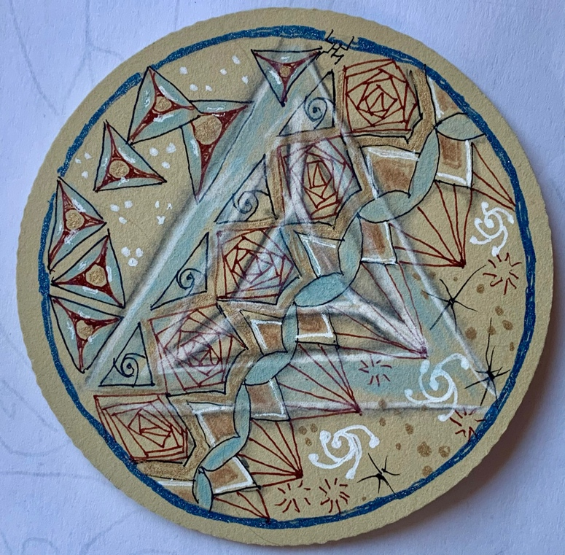

Triangle Galaxy Tile for my

CZT AE 2021 Spring class.

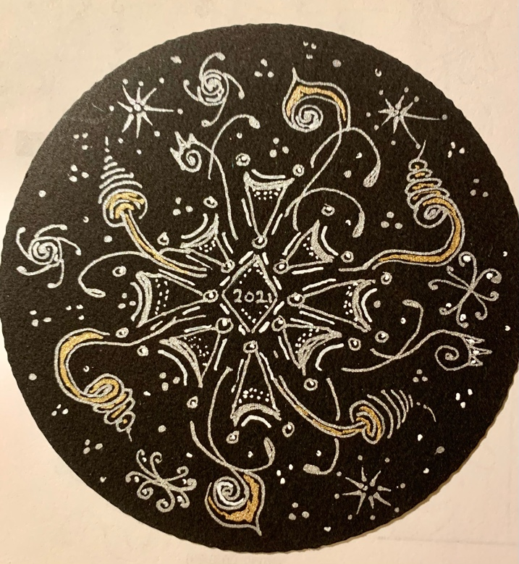

New Year’s Eve Special class. 12/31/20

Me, with my mask at the ready

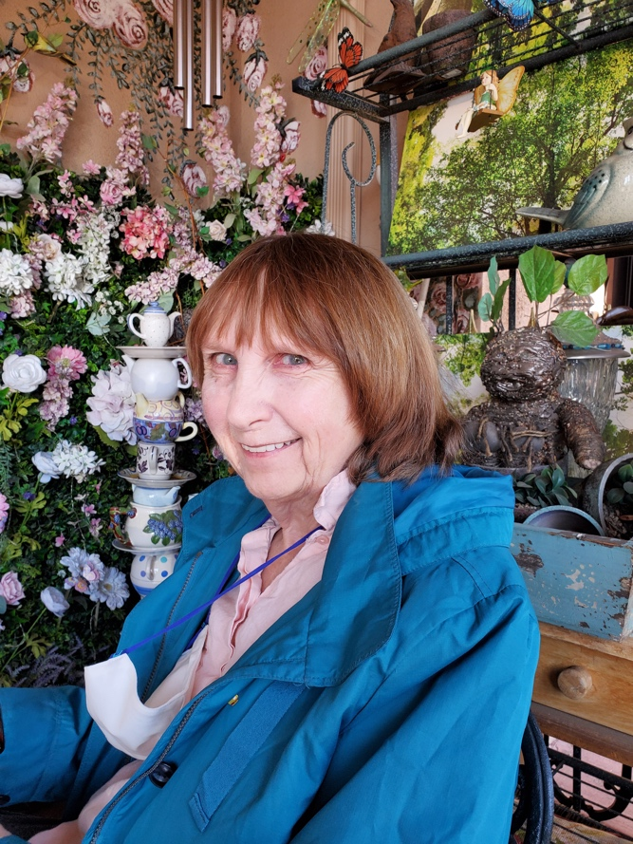 At an Arizona Tearoom in 2020.

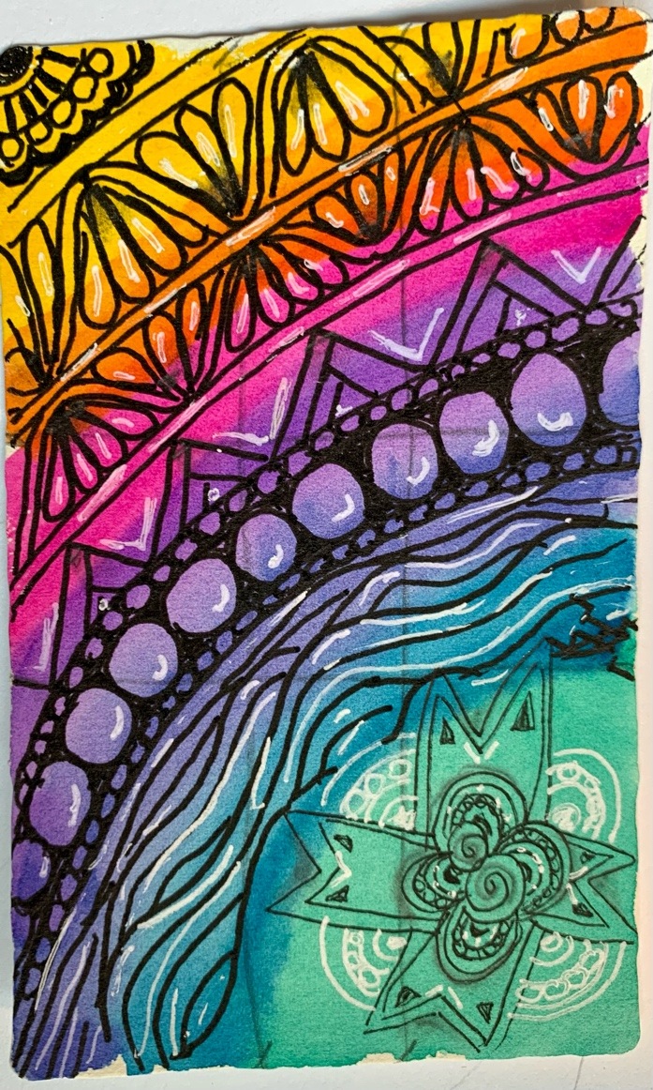

Sara Cruz Rainbow tile. 2020

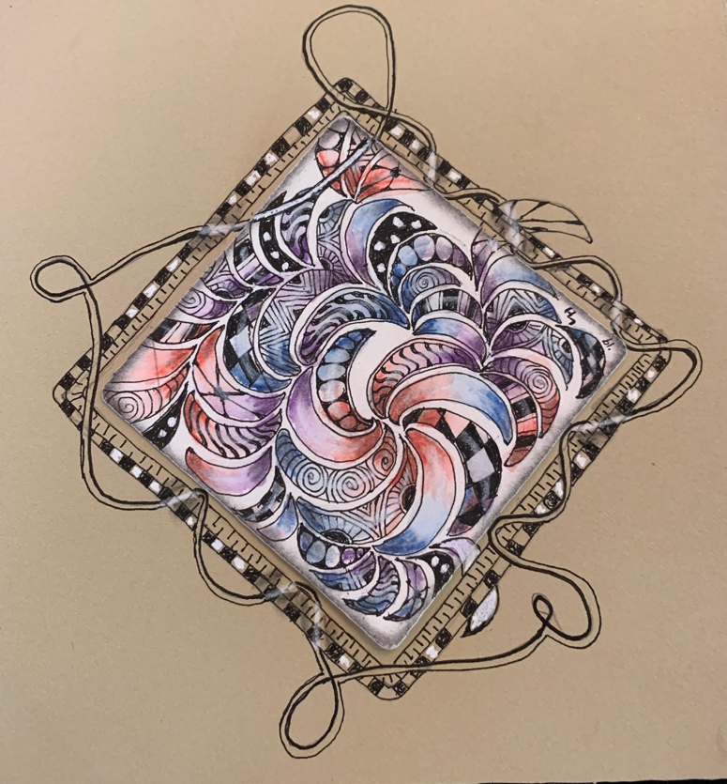

Opus tile from a 1440 class 9/2019

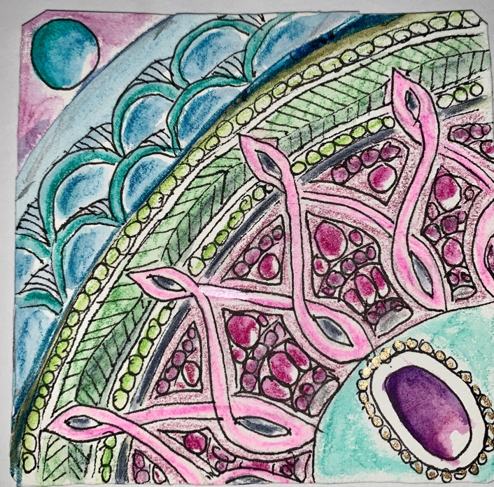

Facebook class I taught Aug 2020

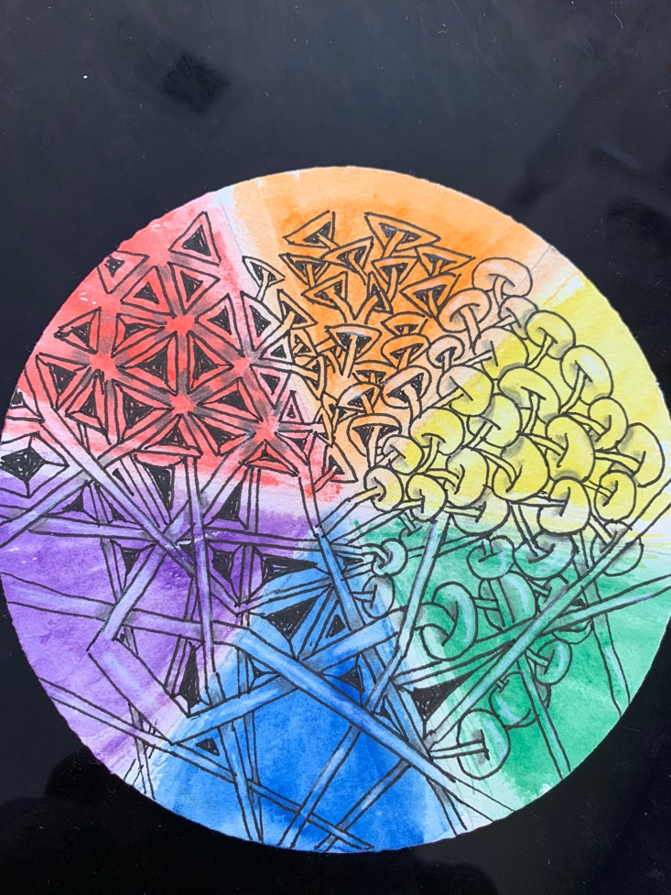 Rainbow Tile from 1440 class with

Rick Robert’s and Maria Thomas

10/2019

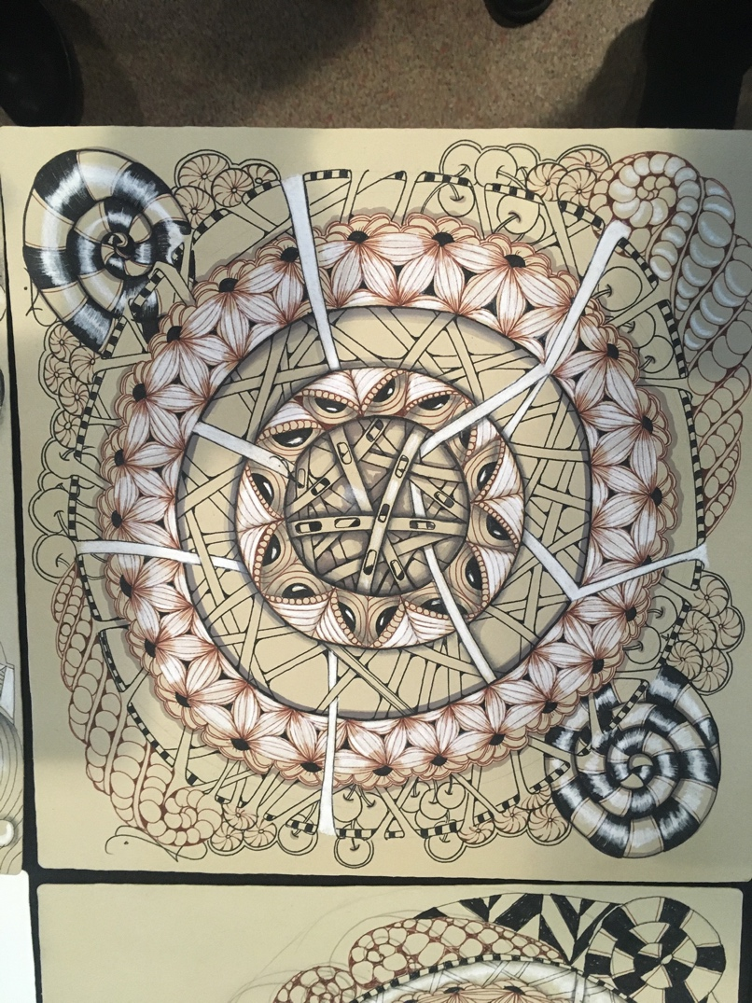

Renaissance Opus tile from a 1440 class

3/2019

Twig Tangle class.1/2021

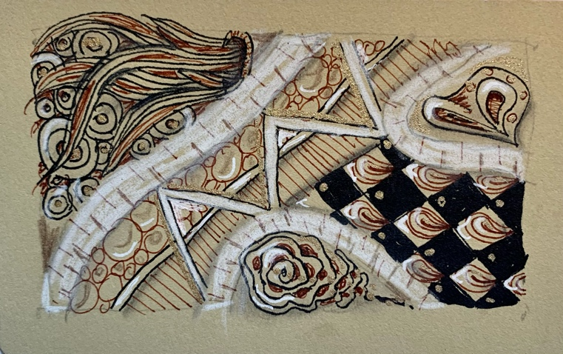

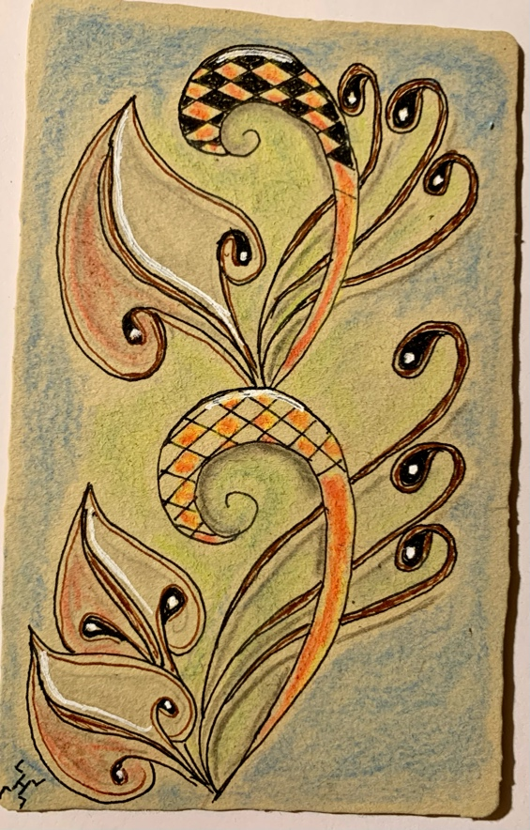

Art Deco Inspired tile 12/2020

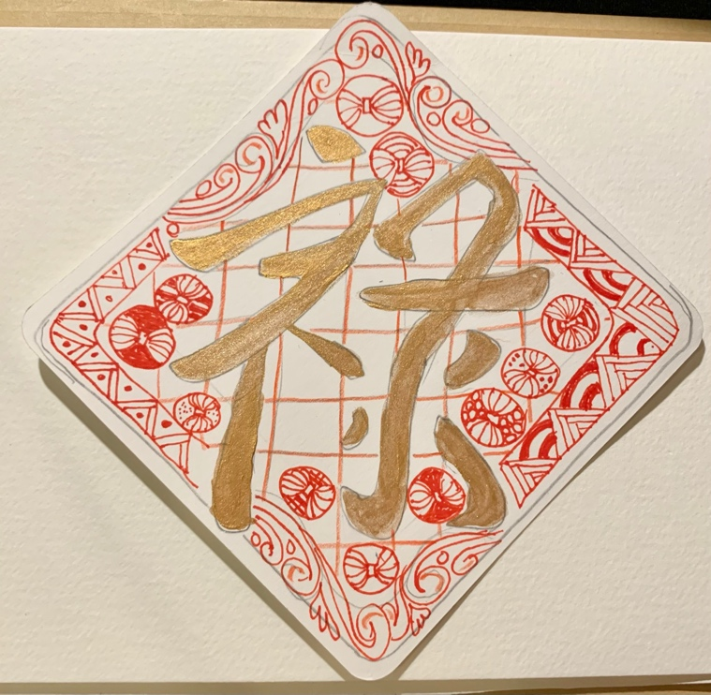

Chinese New Year tile 2/2021

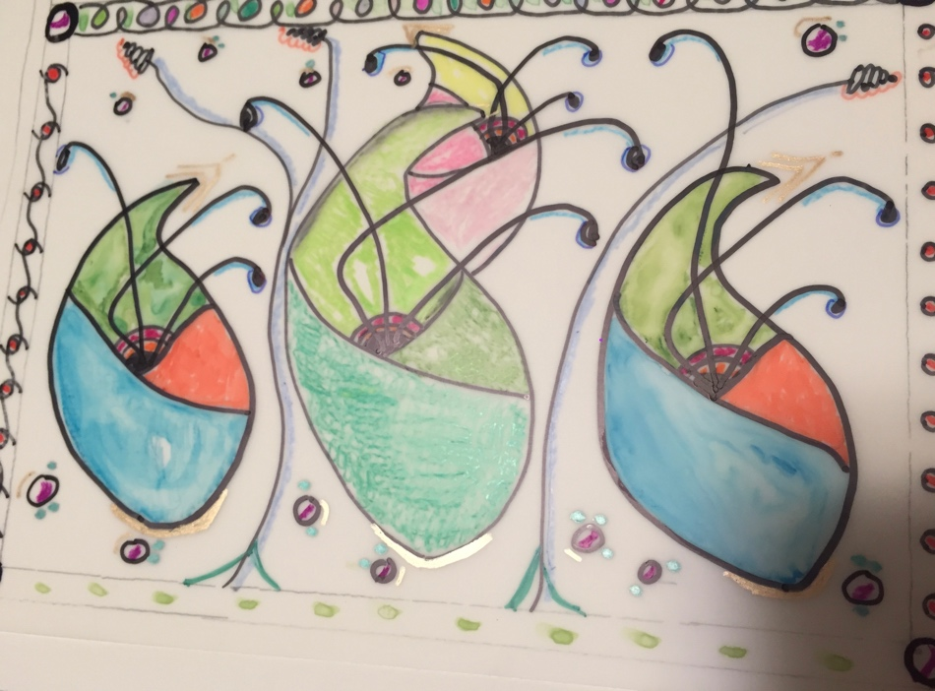

Class tile 7/2020

Drawn in translucent velum, cut out, taped in a circle.

Used as a luminaries with a battery powered “candle” inside

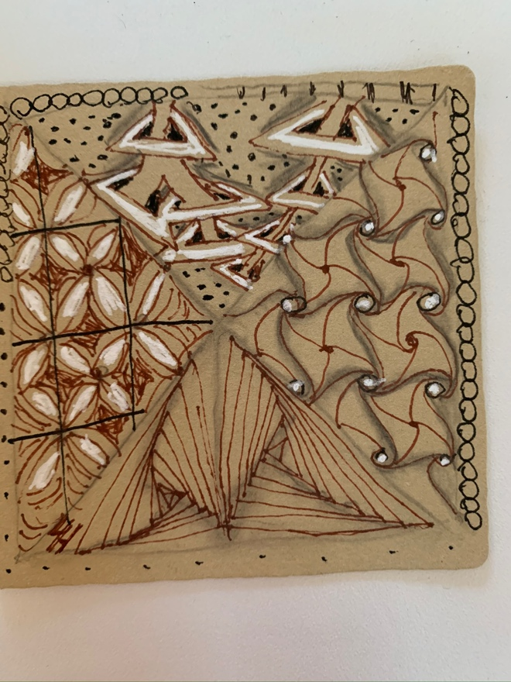

C lass tile 4/2020

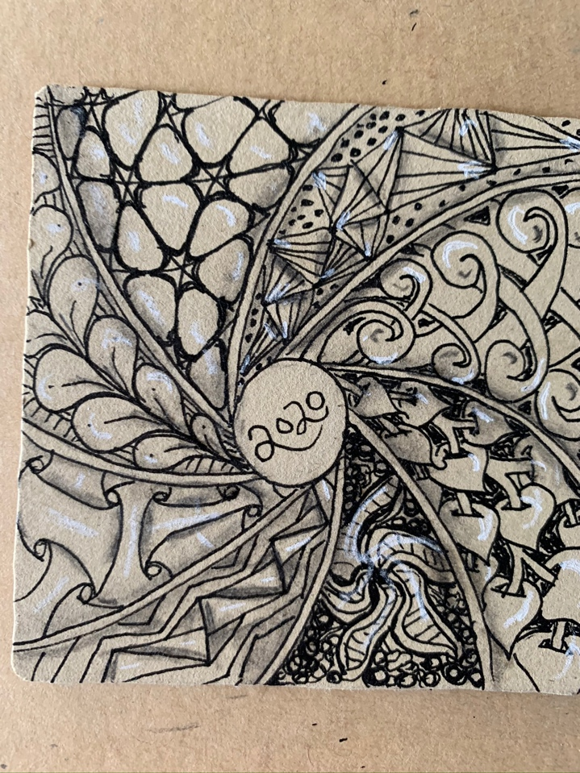

Peaceful Tangles Retreat tile 3/2020

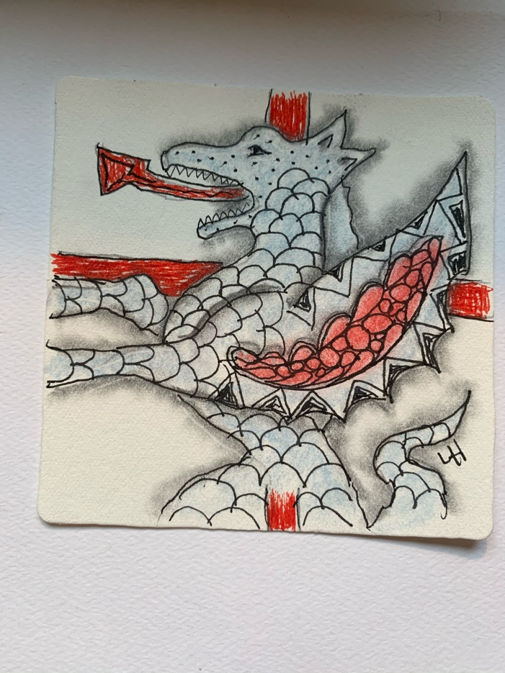

Feast of St. George Day Class I taught

4/2021

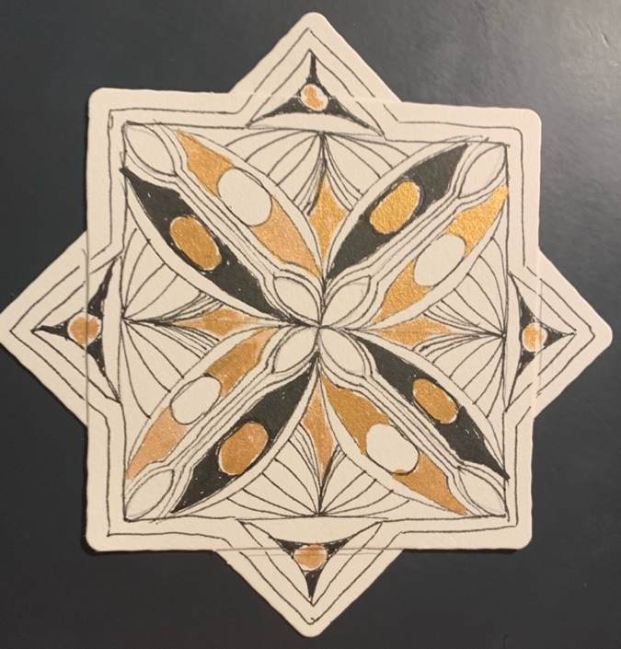

Siblings Day class tile featuring the tangle. Sistar 4/21

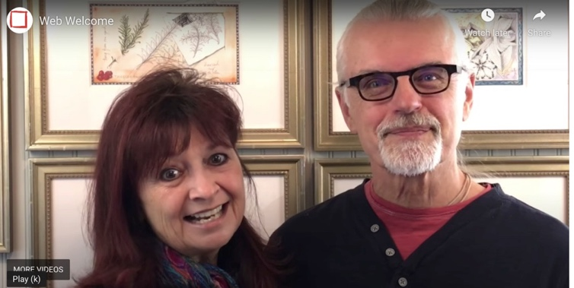

Maria Thomas and Rick Robert’s, Founders.

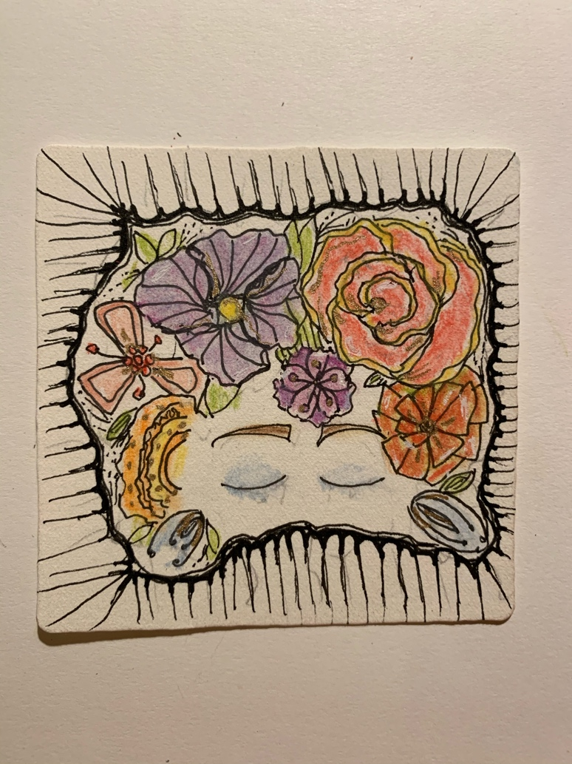

Cinco de Mayo class in 5/1/21

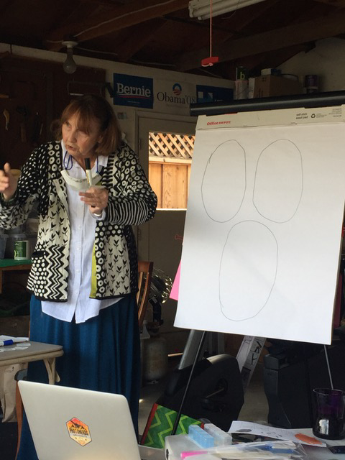“Fully Vaccinated “ class held outside, me in the garage, students socially distanced down the drive way

4/3/21

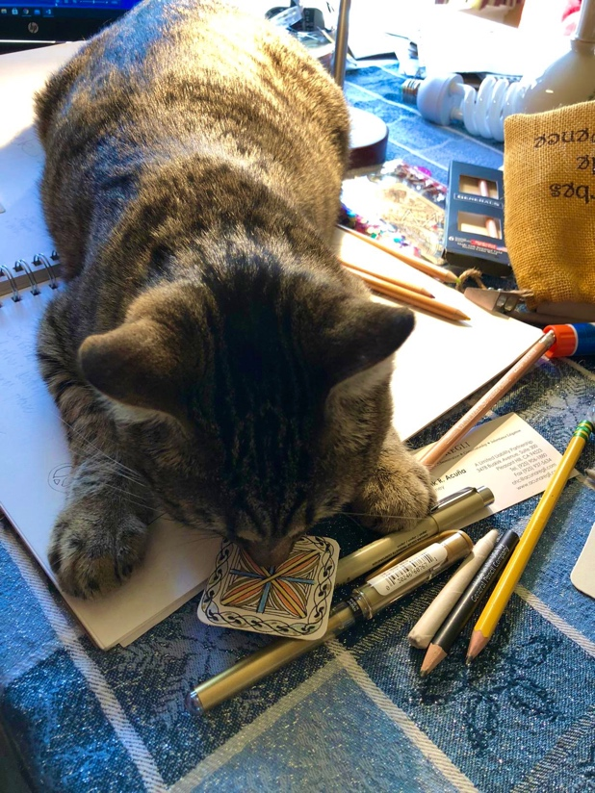

My cat, Twiggy, loves to tangle too.

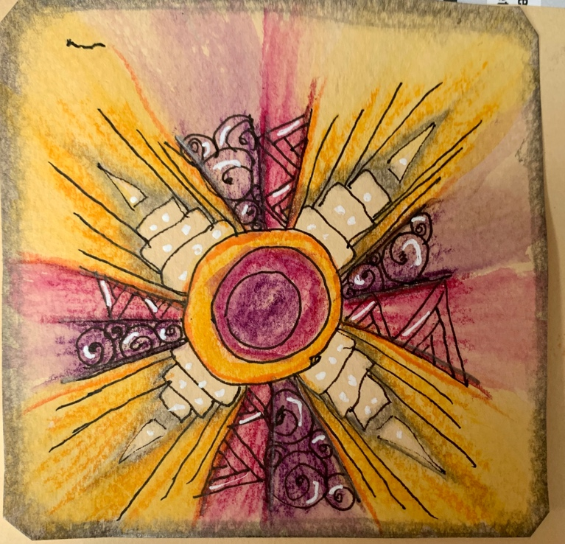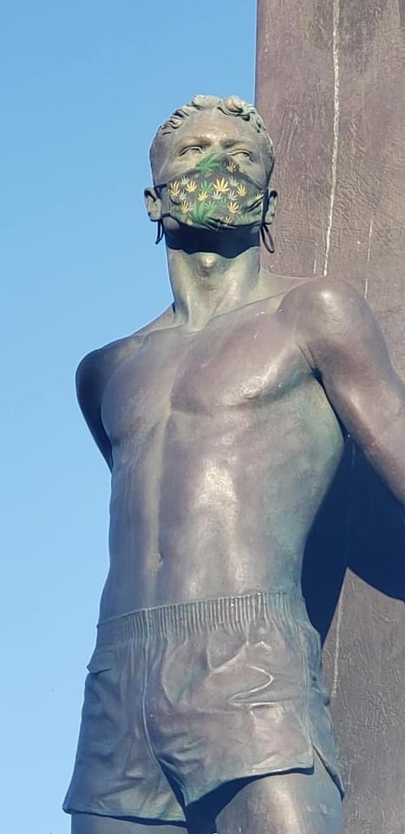The Santa Cryz Surfer Statue during Covid

Facebook class. 2020

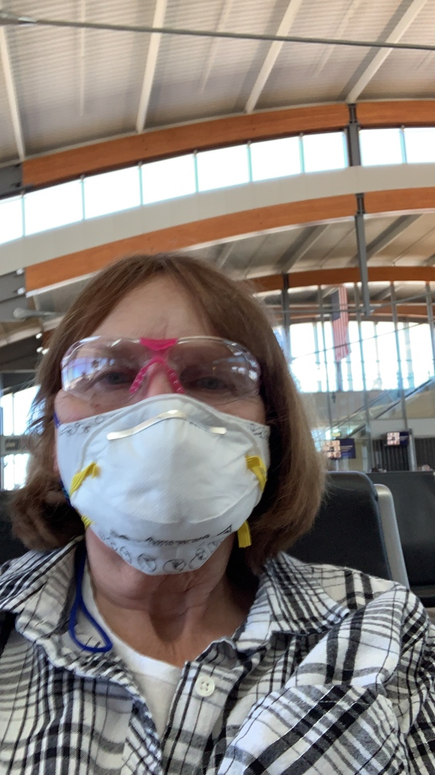

Me, at the airport, with protective glasses and a mask in, ready to fly.

Books I made to hold Zentangle tiles. The pages are

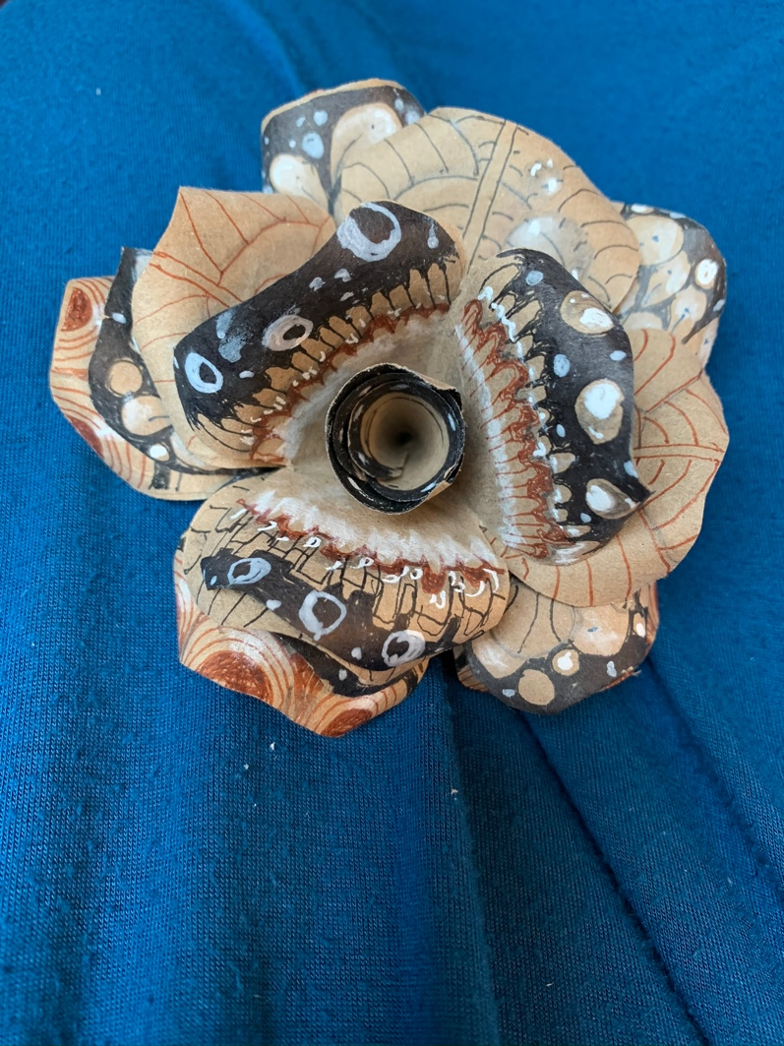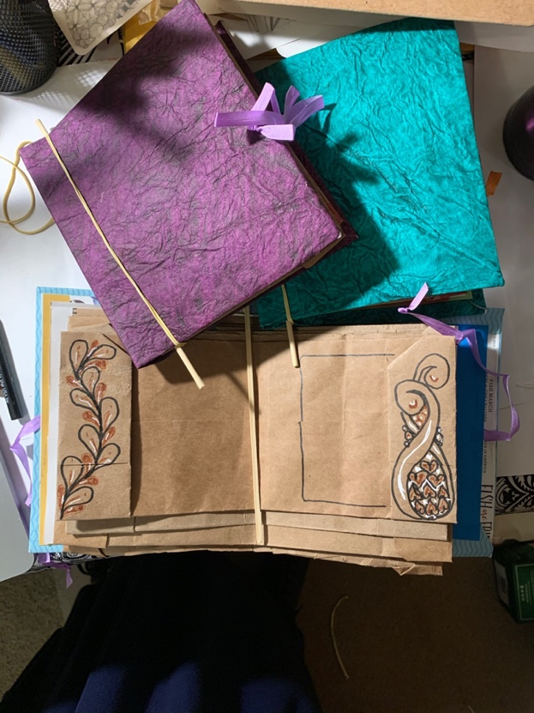Reused paper bags. I got that idea from Tomomi Galeano’s paper bag rose class.

Me, in my studio

